**ERASMUS MUNDUS JMD DYCLAM**

Curriculum and modules

**DYCLAM mobility**

International organisations such as the UNESCO or European organisations such as the Council of Europe are really concerned about Cultural Landscapes. Indeed, Cultural Landscapes and Heritages are at the very heart of important things that are happening in our world and societies regarding environment, social and economic territorial development. In order to understand the whole concepts and theories related to different fields of study concerned (urban planning, architecture, archeology, geography, environment, economics, anthropology, communication …), transversal know-hows are needed using applied methodologies and fieldworks.

Physically and intellectually, mobility in DYCLAM is necessary. It makes students understand cultural diversity, human and territorial development.

**MOBILITY 5 INSTITUTIONS, 5 PERSPECTIVES, 5 EXCELLENCES**

Dyclam is a 2-year curriculum of exchanges and applied education

• Semester 1: University of Saint-Étienne, Site Le Corbusier, France

• Semester 2: Polytechnic Institute of Tomar, Tomar, Portugal

• Semester 3: National Museum of Natural History, Paris, France

• Semester 4: two months of studies at the University Federico II, Naples (Italy) or at the University of Stuttgart (Germany), followed by a 4-month compulsory internship on the field or in a laboratory

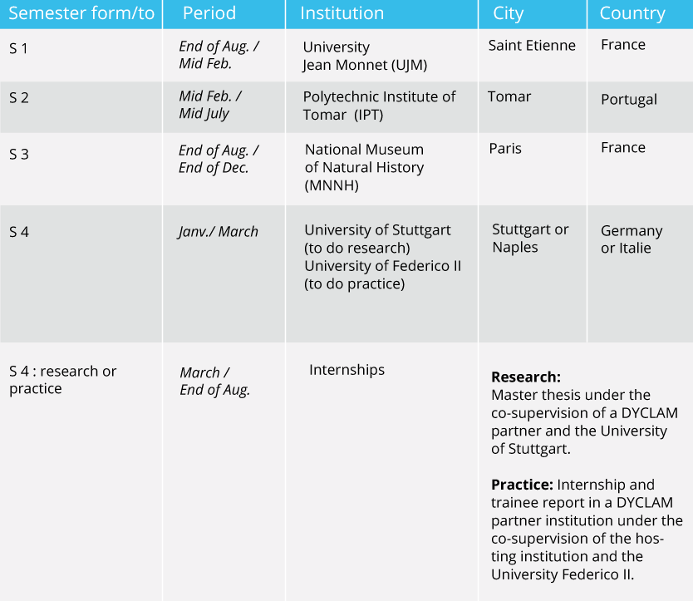

**Awarded degrees**

At the end of the curriculum, successful students will receive a joint degree DYCLAM along with the following:

* **Master Systèmes, Territoires, Environnement, Patrimoines spécialité Métiers des patrimoines** of the University Jean Monnet at Saint-Etienne
* **Master Sciences de la nature et de l’homme, Mention Evolution, patrimoines naturels et sociétés, SpécialitéEnvironnement, Développement, Territoires et Sociétés** » of the National Museum of Natural History, in Paris.
* **Mestrado em Técnicas de Arquelogia – Area de Especializaçao em Gestao do Patrimonio Cultural** of the Polytechnic Institute of Tomar

Depending on their choice of mobility for the 4th semester, one degree will be added among:

* **Master Materiali e tecniche costruttive per il recupero del paesaggio culturale mediterraneo** of the University Federico II of Naples
* **Zeugnis über die Masterprüfung im Studiengang Romanistik** of the University of Stuttgart.

**CURRICULUM**

### Languages of teaching are French andEnglish (as supporting help).Students receive languages lessons in Portuguese, Italian, andGerman, with a specific focus on the practice of French.

**How to be part of DYCLAM?**

#### Admission criteria

#### Applicants must hold a bachelor degree (or any nationally recognized first cycle degree equivalent to 180 ECTS). Regarding the different professional opportunities in the field of cultural landscapes and heritage management, applicants can hold a bachelor diploma in Humanities, Planning, Urbanism, Architecture, Law, Natural sciences, Social Sciences, Chemistry, Tourism, Physics, Engineering, Design, and Art.

Bachelor students having already obtained at least 150 ECTS may apply but they will be admitted only if they are successful before the summer break.

**Application procedure**

Candidates must fill and sign an application form and enclose the following application documents:

* A CV, in French or in English in Europass format (with photo)
* Certified photocopy of the Bachelor degree (or equivalent) with French or English certified translation
* Certified photocopy of transcripts with French or English certified translation
* Language proficiency (French: DALF C1, English: IELTS 6, TOEFL 550, TOEFL internet-based at least 90, TOIC at least 650)
* 2 recommendation letters in French or in English
* A letter of motivation (both typed and hand-written) in French or in English
* A scan of your passport/national ID
* A scan of your birth certificate (with certified translation in French or English)
* A resident or professional certificate proving your current home address

**Scholarships and financial supports**

### C:\Users\MOSTAFA\Desktop\declam\Tab-bourses-2016-GB.gif